# Project Development Phase

**Delivery of Sprint-2**

|  |  |
| --- | --- |
| **Date** | 05 Nov 2022 |
| **Team ID** | PNT2022TMID23311 |
| **Project Name** | Analytics for Hospitals' Health-Care Data |

**Project Development Phase:**

**Sprint-1:**

* Data Collection
* Data Preparation

**Sprint-2:**

* Data Exploration

**Sprint-3:**

* Dashboard Creation

**Sprint-4:**

* Report Creation
* Story Creation

# Sprint-2:

**Data Exploration:**

* **Admission_Deposit by Hospital_region_code colored by City_Code_Patient**
* **Bed Grade and City_Code_Patient for Hospital_region_code**
* **Admission_Deposit and Available Extra Rooms in Hospital for Hospital_region_code**

colored by Hospital_region_code

* **Available Extra Rooms in Hospital and Bed Grade by Hospital_region_code**
* **case_id by Hospital_code**
* **patientid by City_Code_Hospital colored by City_Code_Hospital**
* **Type of Admission for Type of Admission**
* **Visitors with Patient by Age**
* **case_id for City_Code_Hospital**
* **Ward_Facility_Code hierarchy colored by Ward_Type**

**Admission_Deposit by Hospital_region_code colored by City_Code_Patient**

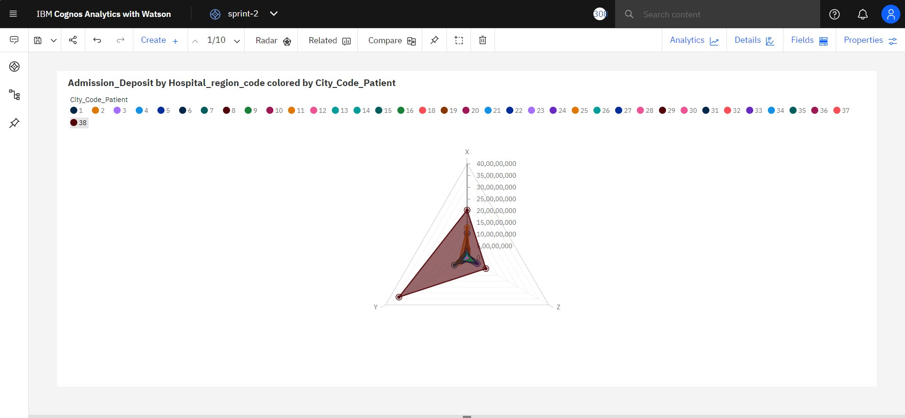

**Bed Grade and City_Code_Patient for Hospital_region_code colored by Hospital_region_code**

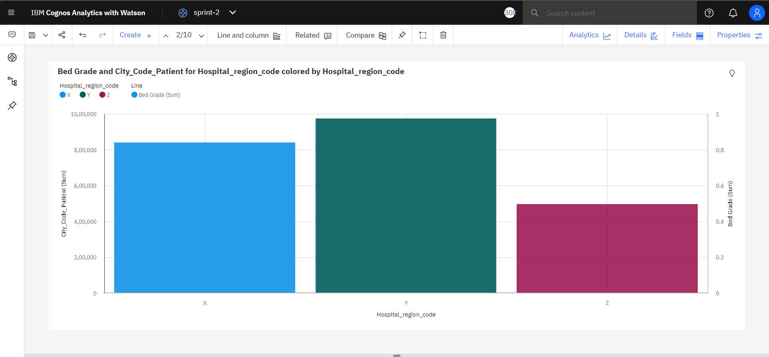

**Admission_Deposit and Available Extra Rooms in Hospital for Hospital_region_code colored by Hospital_region_code**

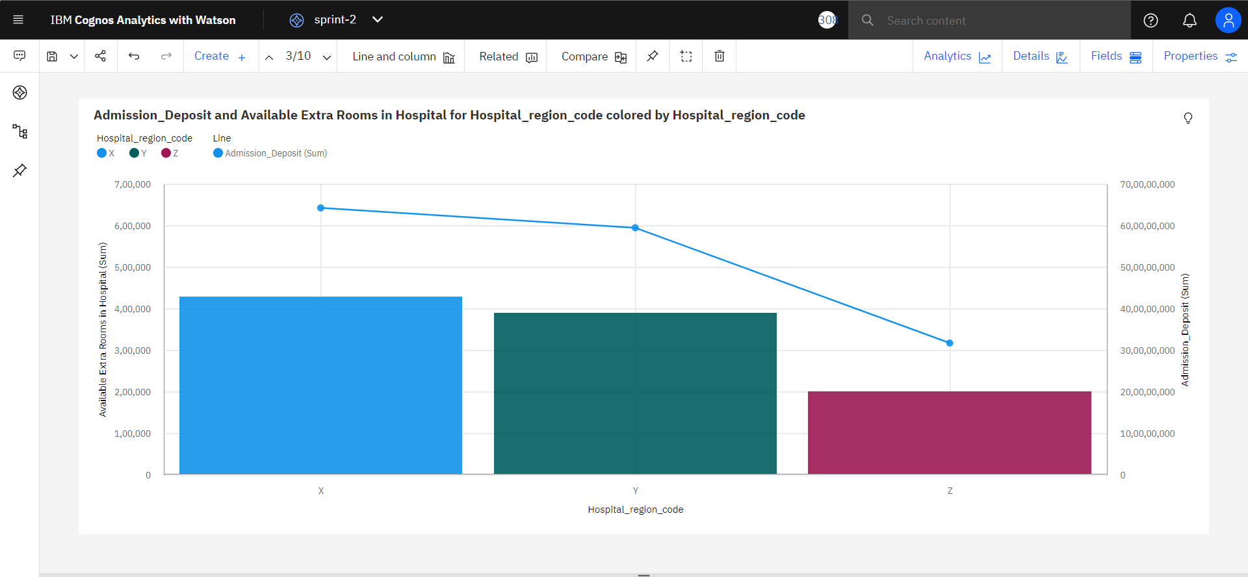

**Available Extra Rooms in Hospital and Bed Grade by Hospital_region_code**

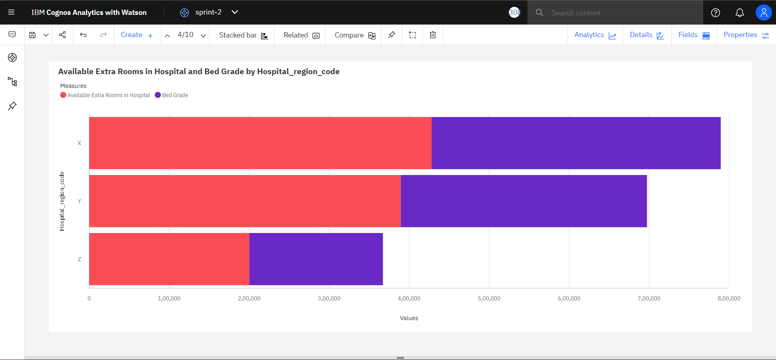

**case_id by Hospital_code**

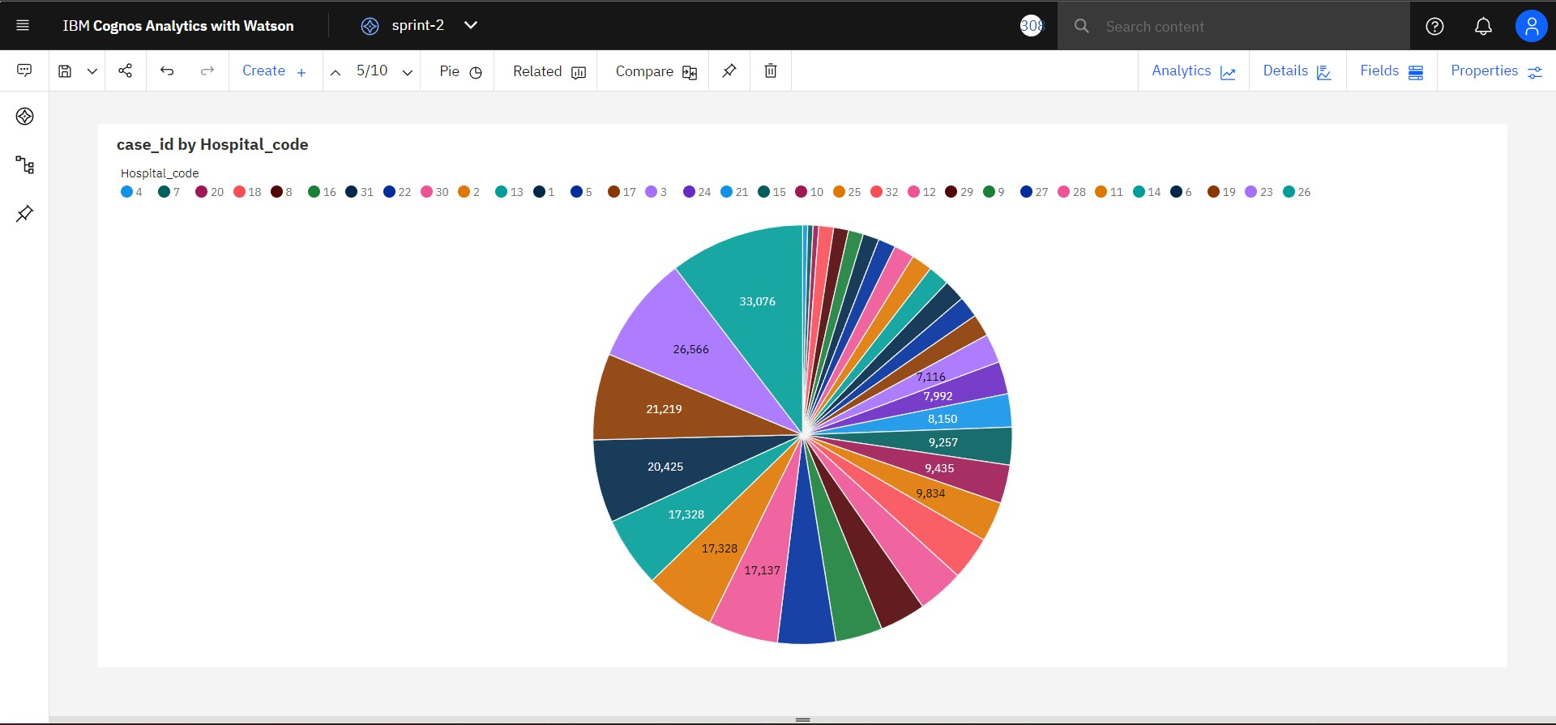

**patientid by City_Code_Hospital colored by City_Code_Hospital**

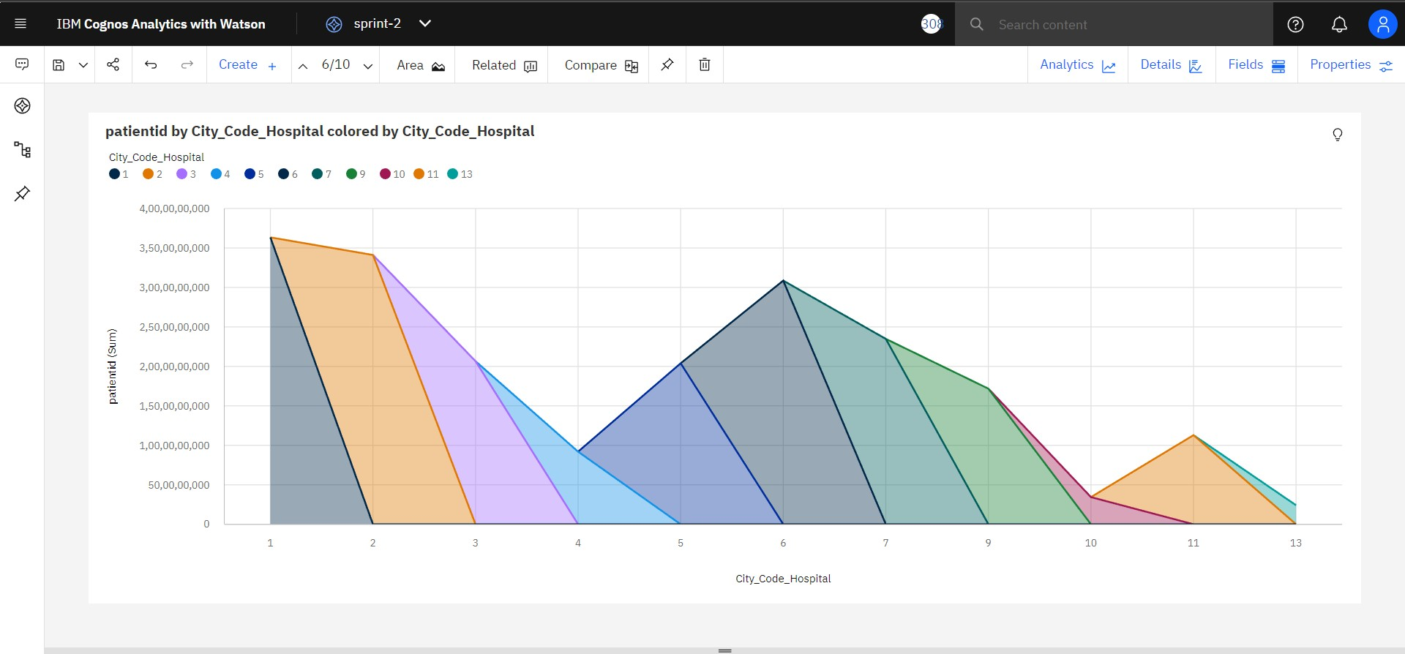

## Type of Admission for Type of Admission

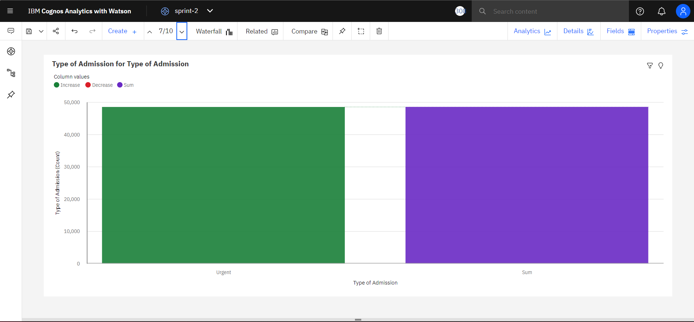

**Visitors with Patient by Age**

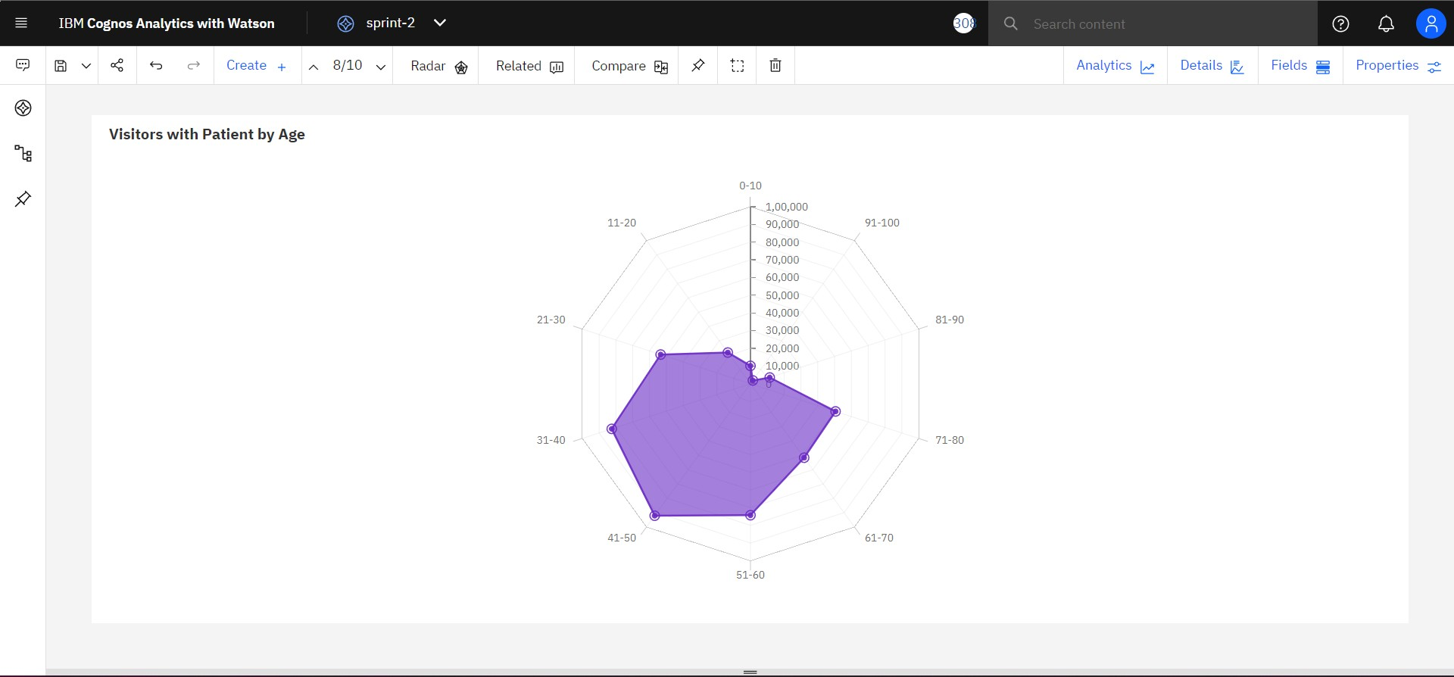

## case_id for City_Code_Hospital

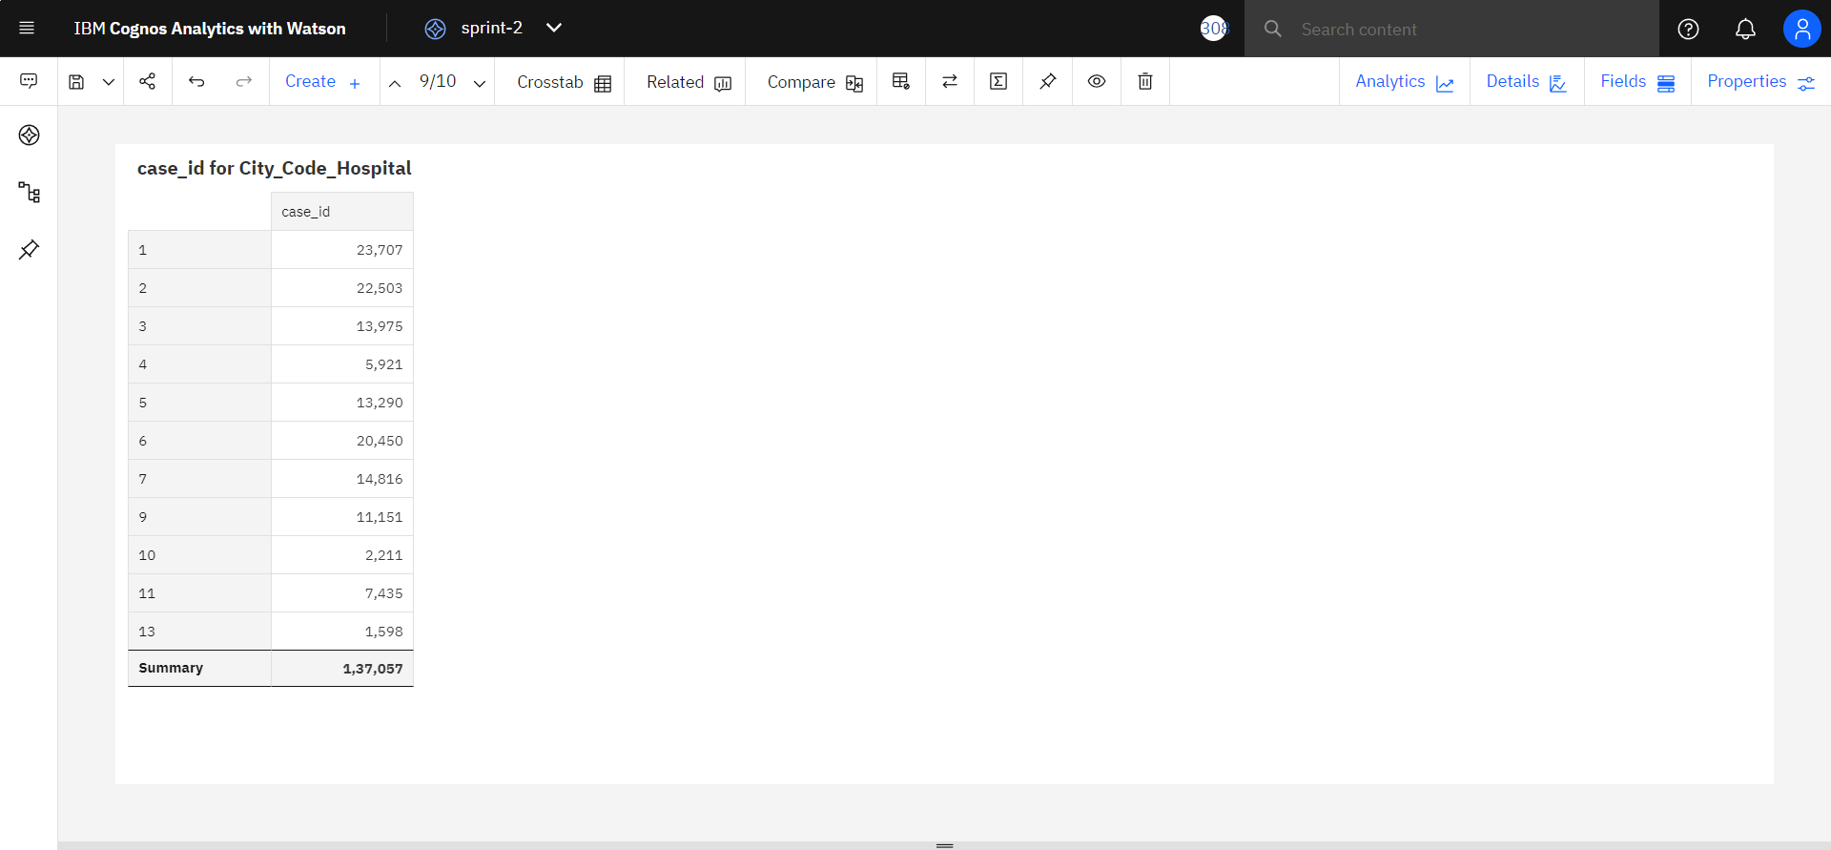

**Ward_Facility_Code hierarchy colored by Ward_Type**

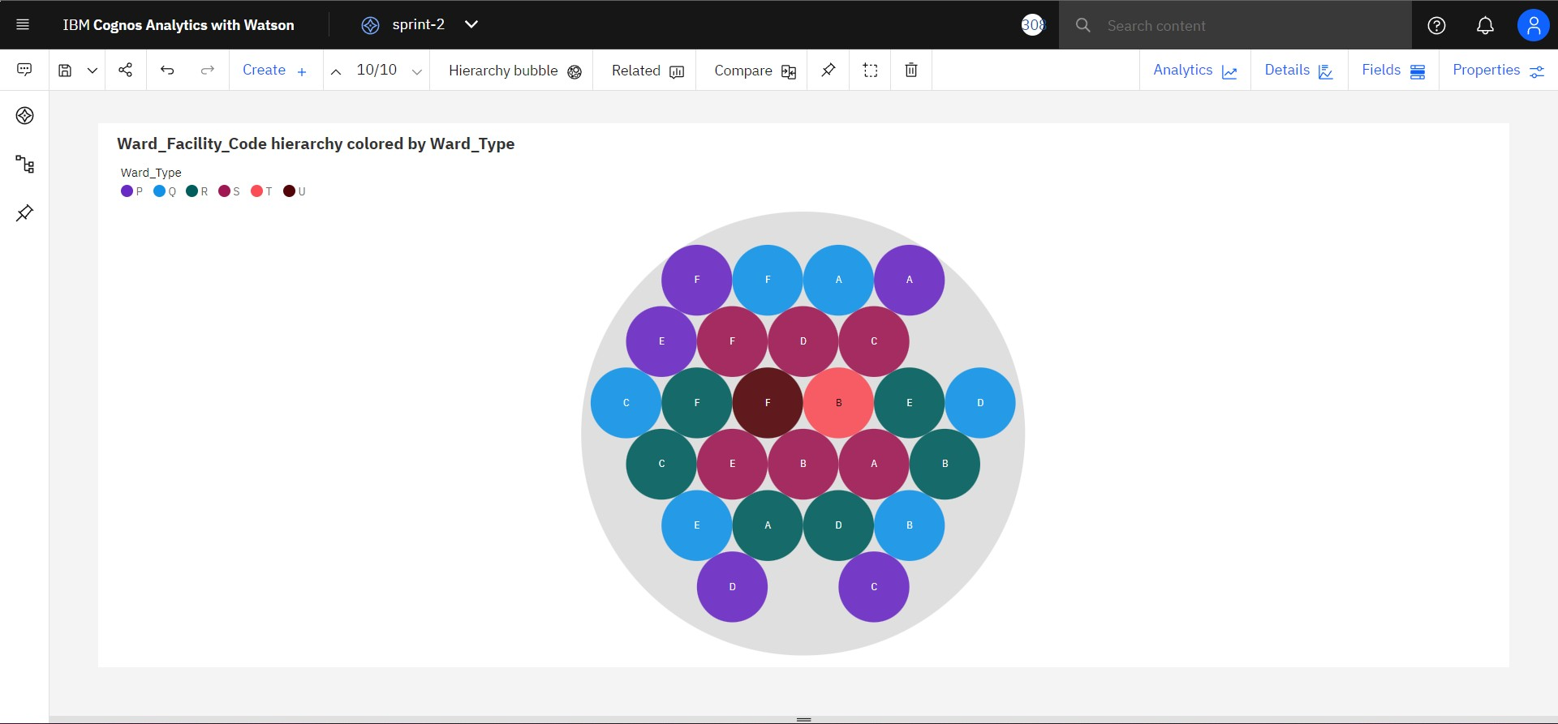

# Prepared data link :